**Replace Concrete Template Class With Abstract Template**

|  |  |  |
| --- | --- | --- |
| *a nonabstract class serves as template for subclass implementations* |  | *pull up the template to its own abstract class and rebalance the class hierarchy* |

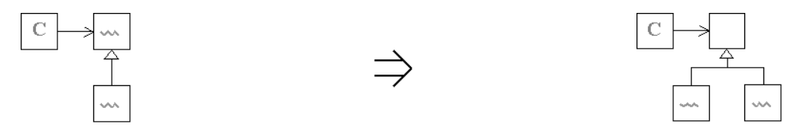

**Context:**

See also : [Replace Concrete Interfacing Class With Explicit Interface](https://web.archive.org/web/20090914101200/http:/www.refactoring.be/thumbnails/rtn-rcicwei.html)